Traffic Violation Analysis using Hadoop

By,
Vinay Chennupati (305079520)
Goutham Kumar Pola (304823433)
Sai Kumar Lakadram (305091194)
Department of Information Systems, California State University
Los Angeles

Abstract:

Safety is one of the major issue anywhere. There are a many traffic violations happening every day. It would be very helpful to analyze the traffic violations to identify different types of traffic violations, who marked those violations, areas with a higher number of violations and the gender and the race who have involved in traffic violation etc. These insights will then have the potential to aid in proactive preventive measures by traffic patrol increasing the level of safety in certain area. The dataset we have used is very large and unstructured. So if we store our data set in Hadoop File System it would be very helpful. Hadoop distributed file systems provides scalable and reliable data storage in addition to enabling analytical capabilities over large amounts of data. The Hadoop map reduce architecture model implementation will be instrumental in helping our process and analyze large data sets. In order to analyze our dataset we have used HiveQL because it is very to use if we have SQL background. The utility of using Hadoop to consume large amounts of data and enable analytical insights is what we aim to demonstrate.

Introduction:

There are huge number of traffic violations that has been reported around the USA and the violation rate is significantly growing as per our analysis the number of violation has been increased year by year. Some types of violations are very primitive but these primitive violation causes death in many of the scenarios. There are different types of violations that we have seen in our analysis.

According to the traffic violation report there were a total of 831,777 violations reported in from the year 2009-2015 in and around Washington D.C i.e. an average 328 violations were carried out per day in around Washington D.C. This can potentially enable law enforcement divisions in traffic polices apprehension, violations reduction, and violations evaluation to take proactive measures to control the violations rate and ensure safety.

Background work:

In order to calculate the number of violation that took place around Maryland in Washington D.C, we have carry forwarded our analysis on the data set which we have downloaded from data.gov, and in order to make our analysis unique from other analysis and to add different dimensions to our analysis we have taken Washington D.C as the focal point and from there we have analyzed the data available in order to find the number of incidents that has been recorded in a particular miles vicinity based on the gender and the races that have involved in these incidents. It also include those who have marked these incidents as violations along with what are different type of violations that has been recorded and there count.

Data Storage:

We intend to store our unstructured data in Hadoop Distributed File System (HDFS). HDFS provides reliable and scalable storage for storing and analyzing unstructured data. It runs on top of Linux operating system and this is designed to operate on commodity hardware. Hadoop stores data in blocks thereby providing strategic data processing and fault tolerance. Hadoop was designed to have a Master-Slave architecture in which slaves are data nodes and master is name node.

Querying:

Data stored in HDFS can be queried using different programming languages, for our analysis we used Hive Query Language to extract the data as it provides an SQL-like structure and operates on tables just like an RDBMS, even though it does not strictly follow the full SQL standard. Hive queries are translated into Map reduce jobs which run on top of Hadoop cluster.

Services:

We used Microsoft Azure cloud computing platform as it provides both PAAS (Platform as a service) and IAAS (Infrastructure as a service) in addition to supporting different programming languages. For using Hadoop on Microsoft Azure, Azure HDInsight must be created and deployed. HD Insight provisions Hadoop clusters designed to store and analyze large data sets. HD Insight uses HortonWorks Data Platform (HDP) Hadoop distribution. This provides an ecosystem of components of like Hive, Pig etc.
Analysis of the dataset:

The dataset which we have collected totally consists of 831,777 columns which is a csv file at it is separated by a comma separator (‘,’). This data set gives the information about the number of incidents that are happened in a particular year, in a particular hour, the gender or the race that involved in the traffic violations, the geo location of where the violations that has been marked followed by the reason for marking the violation, by what means the violations has been marked for say (patrol or sensors etc..). So as per our analysis we have found that the number of violation is being increased year after year in and around Washington D.C. In the last 8 years the maximum number of violations is higher during the year 2015 which crossed more than 140,000 violations and the same pattern is observed during 2011. The driver who are involved in the violations are most from the states of Maryland, Virginia, and Washington D.C. The total number of males that have marked in this violations totally constitute 67% and the total number of female’s constitute 33%. Based on the race the number of incidents marked is mostly on the whites which constitute 38% of the total percentage followed by blacks, Hispanic etc.. As per our analysis it is clearly stating that the number of violations that has been marked are mostly by the patrol which actually constitutes the values of close to 700,000 out of 831,777. In our analysis most of the violations are marked due to 6 reason, among them the one that stays top in the list is that violation for not using the belts which is totally constituted of 34% then followed by FATAL accidents and the least stay is due to alcohol consumption which is of 2%.

So our primary focus is to identify the number of incidents marked in and around the radius of 50 miles by taking Washington D.C’s down town as the focal point. We have developed an algorithm to calculate the distance from the focal point to the nearest vicinity based on latitudes and longitudes. As per the analysis the number incidents that has been marked from Washington D.C’s downtown to a radius of 50 miles is higher in the 10-15 miles radius followed by 5-10 miles radius. The frequency of violations are mostly happens during the night time and it is observed that the violations have been marked mostly during the time of 22nd and 23rd hour in a day followed by 8th,0th, 21st hours respectively. The violation that has been made by the males in the radius of 50 miles is also higher from in the radius from 10-15 miles and the same pattern is observed when we carry the analysis for the year 2015 and based on the number of whites that has been marked for violations.

Data Visualization:

Data visualization is projecting the relevant information in pictorial or graphical form. Hive query results can be visualized in Microsoft excel. We have used hive ODBC for data visualization in excel. Apart from Excel there are other powerful tools available for data visualization/dashboard creation like R and Tableau.

Graphical representation of few analysis:

Here are some of visualizations works

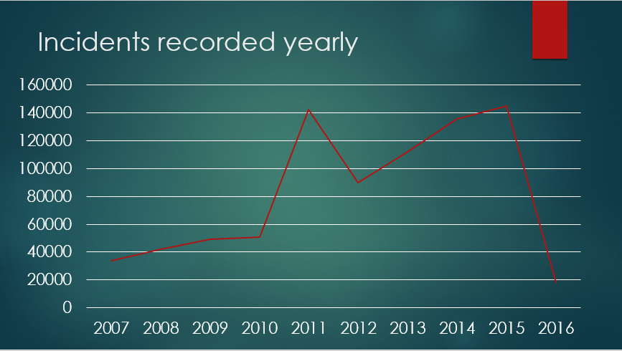
Figure (1) Number of violation marked in different years from 2009-2016

As per the figure (1) if is observed that most of the incidents has been marked in the year 2015 followed by 2011 and the lease was in 2007.

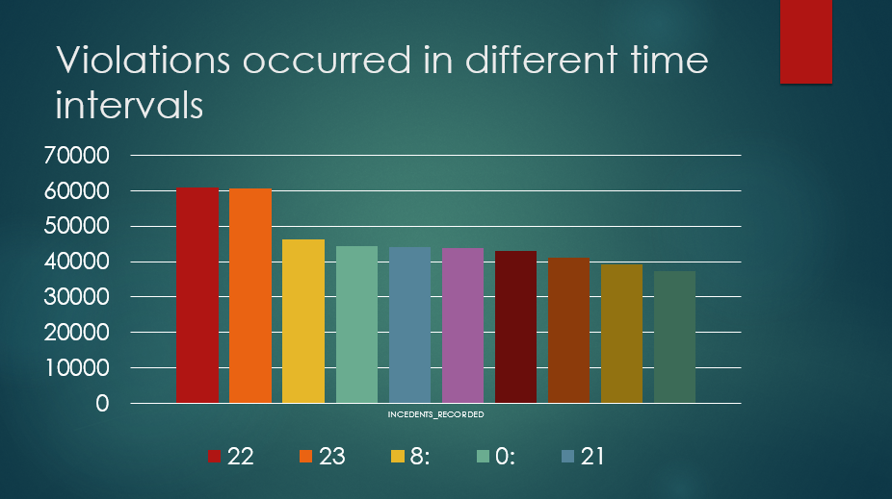
Figure (2) Violation occurred on a particular hour in a day.

As per the figure(2) we can able to see that most of the violations has been happened in between the hours 21-24 in a particular day.

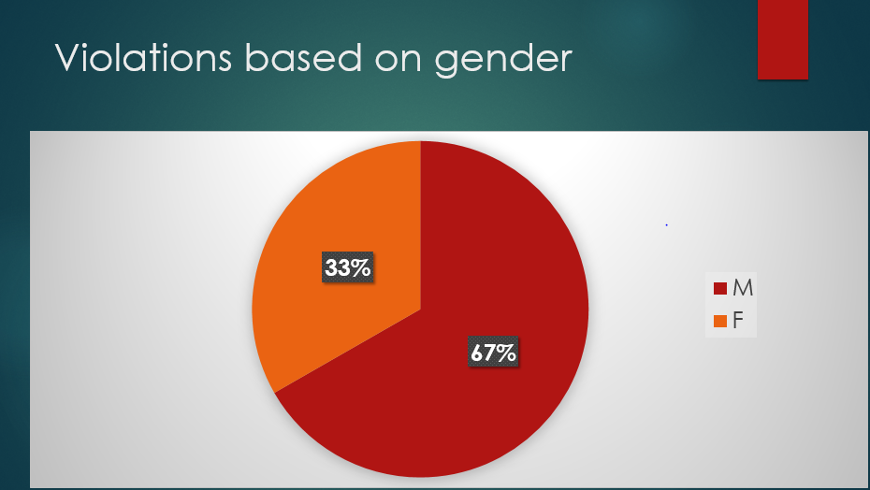 Figure (3) Violation segregated based on gender.

As per the figure(3) we can able to see that the number of violation that has been involved made by males are high when compared with female’s and as it clearly seen for the pie chart that more than 50% .

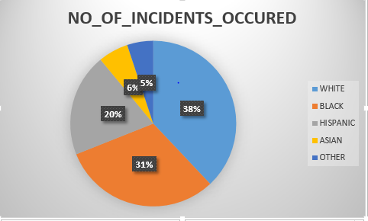
Figure (4) Violation segregated based on races.

As per the Figure (4) we can able to clearly see that among the races the more number of violation has been marked for the white people followed by blacks and Hispanic.

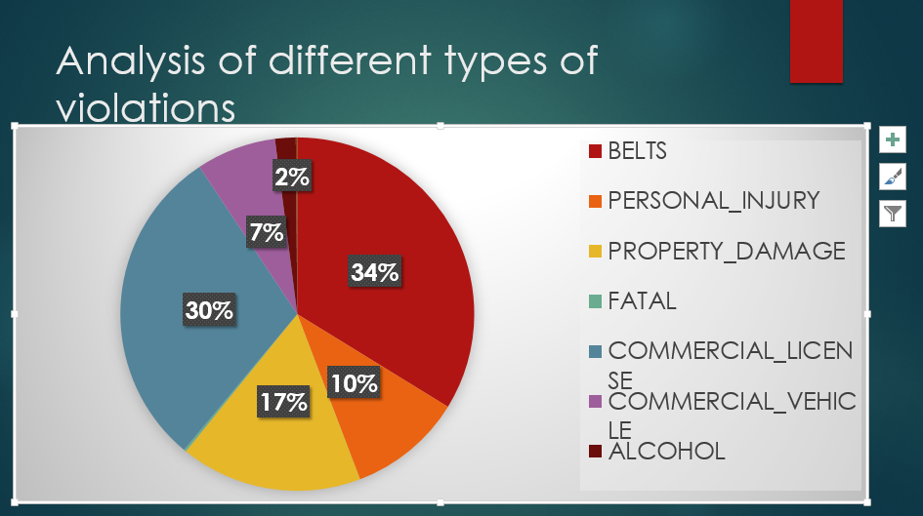
Figure (5) Violation segregated based on races.

The above pie chart shows the reasons for why the violations has been marked and it is clearly showing that the violation has been marked maximum for not using the belts while driving and the least has been due to alcohol.

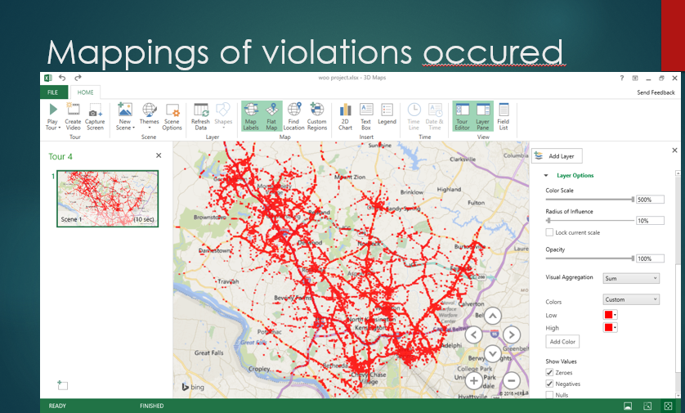
Figure (6) Map shows the violations recorded in a radius of 70 mile from Washington D.C down town.

As we already said that we too Washington D.C as the focal point to our project and carry forwarded our analysis from there the above map shows all the violation that has been encountered in a radius of 70 miles from Washington D.C downtown.

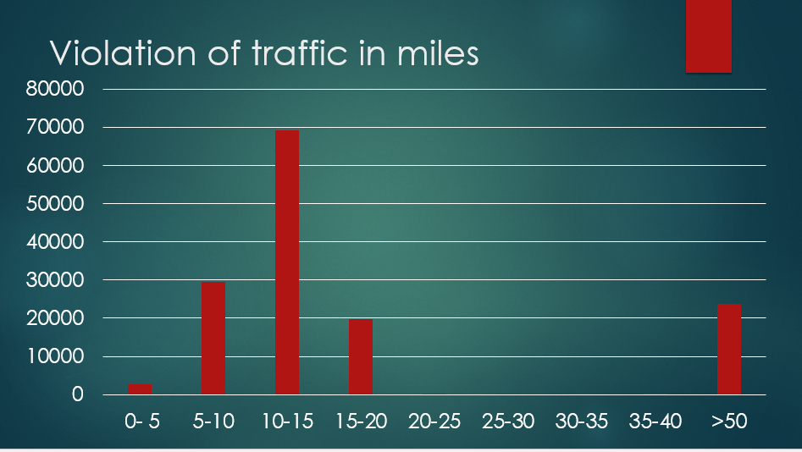
Figure (6) Bar chart shows the violations recorded in a radius every 5 miles radius from Washington downtown.

We have carry forwarder on analysis by considering the violations occurred for every file miles as show in the bar chart above and this chart clearly states that more number of violation has been occurred in a radius of 10-15 miles, and the same pattern continued for the analysis that we have done likewise on the number of incidents that was marked in 2015 in a particular radius and the number of males involved in violation in a particular radius.

Conclusion:
In the overall project we have learned to write queries in order to analyze the data, the functioning of map reducer function the usage of azure cloudberry storage blob visualization of the data with the help of Excel by using ODBC driver etc..

In our detailed analysis we have analyzed the data that for the traffic violation that has been happened in and around Washington D.C as the focal point. With this kind of analysis we found the traffic violation rate is high in the 2015 when compared with previous 7 years and the frequency of the violation are high during the time 20:00-0:00, males have involved in more traffic violation rather than women, White are in the top of the list in the traffic violations when segregation comes to races. And most of the violations are marked by patrol. When we fix Washington D.C as the focal point to take our analysis forward we have made the analysis for every 5 miles radius and found that the violations are more in a radius of 10-15 from that particular radius.

Dataset URL:
http://catalog.data.gov/dataset/traffic-violations-56dda

GitHub URL:
https://github.com/gouthampola/Traffic-Violations

References:
http://blog.cloudera.com/wp-content/uploads/2010/01/6-IntroToHive.pdf
http://blog.cloudera.com/blog/2013/04/demo-analyzing-data-with-hue-and-hive/

